Public Safety Warning: Organized Stalking

The corrupt police officers and their vigilante minions who are manipulating members of this community are exactly the same type of people who psychologically tortured and murdered the civil rights activist Jean Seberg.

Organized stalking and harassment is not just illegal; it’s cowardly and evil.

You should give some serious thought to what kind of person you are – and whose example you should follow. Such choices define you as a human being, and they can inspire you or haunt you for the rest of your life.

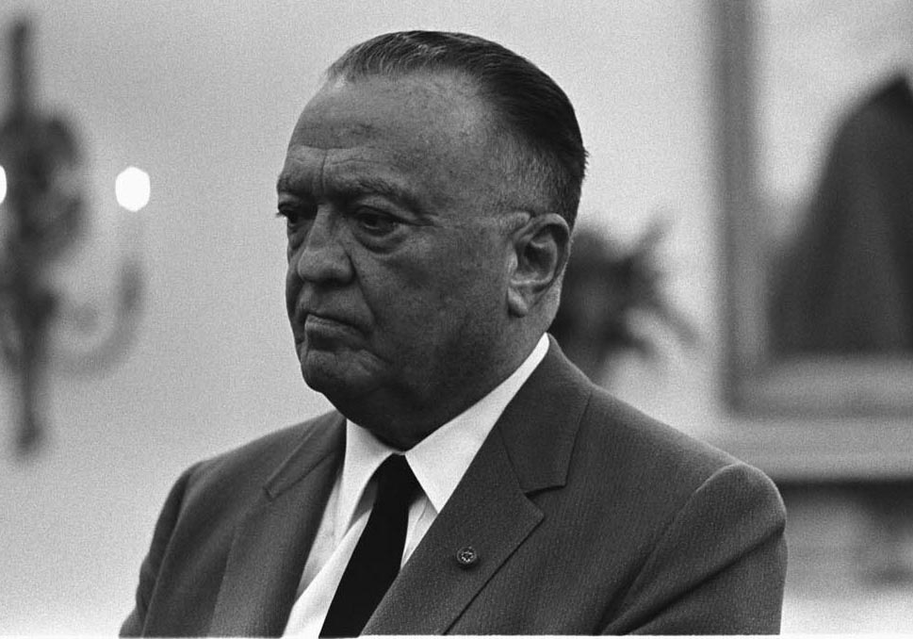

Jean Seberg J. Edgar Hoover

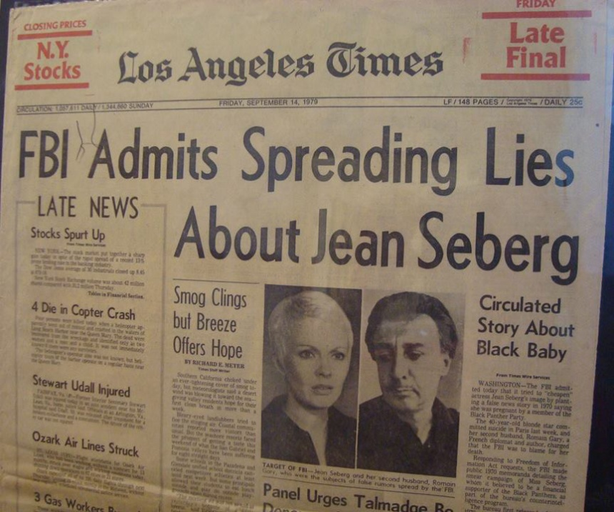

FightGangStalking.com

